CuraAid Administrator Manual
This manual is for platform administrators. Patient and doctor steps are in USER_MANUAL.md.
Admins verify doctors, manage users (warn / suspend / block), handle complaints, review feedback, oversee appointments, and maintain the pharmacy catalogue and orders.

1. How to start
Same as the user app: backend on port 8000, frontend on port 3000.
cd C:\Users\root\Downloads\FYP\backend
php artisan serve --host=127.0.0.1 --port=8000
cd C:\Users\root\Downloads\FYP\Frontend\my-react-app
npm start
Open http://localhost:3000/admin/login (or Login → Login as Admin).

2. Admin login
Figure: Admin login
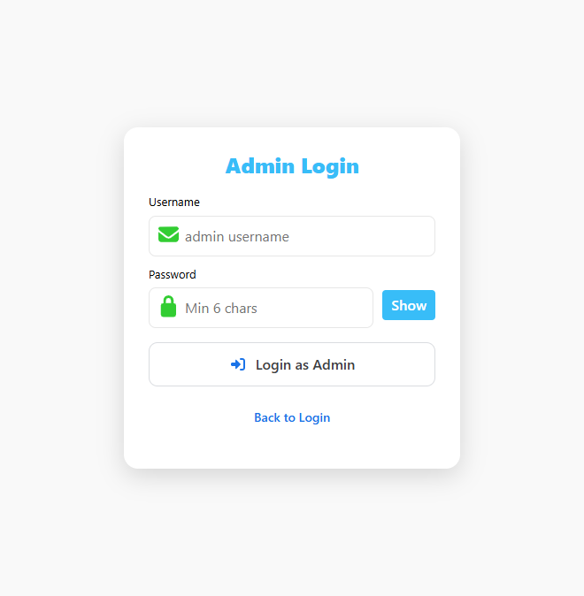
Field | Demo value
Username / Email | admin@gmail.com
Password | Admin@pk

Click Login as Admin. You are taken to the admin Dashboard.
Use a separate browser profile if you also need to stay logged in as a patient or doctor at the same time.

3. Admin sidebar
Open the hamburger menu (☰). Admin items:
Menu | URL | Purpose
Overview | /dashboard | Counts, pending documents, reports, analytics
Documents | /documents | Doctor verification (approve / object)
Reports & Actions | /reports | Complaints, warnings, suspend, block, feedback
Users | /users | All patients and doctors; warn / suspend / block
Settings | /admin/settings | Admin profile and team
Logout | — | Ends the admin session

Pharmacy catalogue work is on the public Pharmacy page while you are logged in as admin (/pharmacy).

4. Dashboard (Overview)
After login you see:
- Total Doctors and new doctors this month
- Total Patients and new patients this month
- Pending Documents — verification files waiting for review
- Active Reports — open complaints that need action
- Recent doctor documents
- Feedback overview (average rating and distribution)
- Recent reports
- Weekly analytics and recent appointments (platform-wide)
Use Pending Documents as a shortcut to go and approve doctors. Use Active Reports as a reminder to open Reports & Actions.

5. Doctor documents (verification)
Path: Documents (/documents).
Doctors who signed up uploaded:
- Medical license image
- CNIC
- Qualification certificates
- Experience certificates
- PMDC number and license expiry
Tabs typically include All / Pending / Approved / Objected.
To approve a doctor
- Open the row.
- Preview or download each file (opens the stored image/PDF).
- Confirm PMDC number and expiry.
- Set status to Approved.
The doctor then appears in public search and in the Initial Guidance ranking.
To object / reject
- Choose Objected (rejected).
- Enter a reason (for example: “License image is unreadable”).
- Save. The doctor stays off the public list until they re-submit and you approve.
Never approve a doctor without checking the uploaded files. Unverified doctors must not take live patients.

6. Users (warn, suspend, block)
Path: Users (/users).
The page loads every patient and doctor. Summary cards show total users, doctors, patients, and pending verification.
Find a user
- Tabs: All / Doctors / Patients
- Search by name, email, or id
- Role filter
Click a row to open details (phone, email, join date, location, verification).
Account actions (on an active user):
Action | Effect
Warn User | Stores a warning and reason. Account stays active.
Suspend Account | User cannot use the platform until restored.
Block Account | Stronger ban. Same restore path.
Restore Account | Shown when the user is suspended or blocked. Sets status back to Active.
Mark as Verified | Shortcut to approve a doctor profile (same as Documents).

Warnings are also available from a complaint (see next section). Prefer complaint-linked actions when the issue came from a patient report, so the case is closed in one place.

7. Reports, complaints, and feedback
Path: Reports & Actions (/reports).

7.1 Complaints
Patients can file a complaint against a doctor. Each row shows complainant, respondent, category, priority, description, and optional proof image.
Open a complaint and choose an action:
- Warn — warning on the doctor’s account; complaint marked warned
- Suspend — temporary lock
- Block / Disable — account blocked
- Resolve — close without extra penalty (for example after a misunderstanding)
Always write a short reason. It is stored on the user action log.

7.2 Platform feedback
The same area lists feedback submitted from /feedback (and doctor ratings where available). Use this to spot repeated problems (late consults, rude behaviour, pharmacy delays).

8. Pharmacy catalogue (admin)
Log in as admin, then open Pharmacy in the top bar (/pharmacy).
Patients see Add to Cart. You also see Add New Medicine and Remove on each product.

8.1 Add a medicine
- Click Add New Medicine.
- Fill at least name and price. Recommended fields: dosage, category, type, brand, manufacturer, pack size, unit, indication, usage, description, image.
- Click Upload.
The item is saved in the database (medicines table) and appears for every visitor after refresh. This is the correct way to stock the shop — not the patient cart.

8.2 Remove a medicine
On the product card click Remove. The item is hidden (is_active = false) and no longer appears in search, chatbot matching, or new orders.

8.3 Pharmacy orders
On the right side of the Pharmacy page, Pharmacy Orders lists recent checkouts (name, total, payment method, item count).
Change status with the dropdown:
- Placed
- Preparing
- Shipped
- Delivered
- Cancelled
COD orders start as payment pending. Card demo orders are stored as paid (no real gateway).
Patients add items with Add to Cart and checkout. That does not add a new product to the catalogue.

9. Appointment oversight
The API exposes all appointments to admins. The Dashboard analytics block shows recent appointments (patient, doctor, date, type, status).
Typical statuses:
- pending — waiting for the doctor
- scheduled — approved
- in_progress / completed / cancelled / rejected
Admins do not normally approve clinical slots; that is the doctor’s job. Use this list to investigate complaints (“the doctor never accepted my booking”).

10. Admin settings
Path: Settings (/admin/settings).
- Update the logged-in admin profile
- List other admin accounts
- Create or remove admin team members (super-admin style)
Keep the demo password only on a local machine. Change it before any shared hosting deploy.

11. What admins should not do
- Do not use Add to Cart as a way to “add stock”. Cart is a shopping basket.
- Do not approve doctor documents without opening the files.
- Do not block a user without a stored reason.
- Do not treat chatbot output as a medical diagnosis in any public statement.

12. Demo checklist (viva / marking)
- Login as admin@gmail.com / Admin@pk.
- Dashboard shows doctor and patient counts.
- Documents — open a doctor file; show Approve / Object.
- Users — warn, suspend, restore a test account.
- Reports — open a complaint and apply an action.
- Pharmacy — Add New Medicine, confirm it appears after refresh, place a patient order in another browser, then change order status to Preparing.

13. Admin URLs and APIs
Screen | URL
Admin login | /admin/login
Overview | /dashboard
Documents | /documents
Reports | /reports
Users | /users
Admin settings | /admin/settings
Pharmacy (catalogue + orders) | /pharmacy

Useful API routes (Bearer token from admin login):
- GET /api/admin/users
- PUT /api/admin/users/{id}/status { "status": "suspended"|"blocked"|"active", "reason": "..." }
- POST /api/admin/users/{id}/warn
- GET /api/admin/doctors
- PUT /api/admin/doctors/{id}/status { "status": "approved"|"rejected", "rejection_reason": "..." }
- GET /api/admin/complaints
- POST /api/admin/complaints/{id}/action
- GET /api/admin/appointments
- GET /api/admin/pharmacy-orders
- PATCH /api/admin/pharmacy-orders/{id} { "status": "preparing" }
- POST /api/pharmacy/medicines (multipart allowed for image)
- DELETE /api/pharmacy/medicines/{id}
Full endpoint list: API_AND_CREDENTIALS.txt in the project root.

